Historical and Chronological context of Genesis 1-11

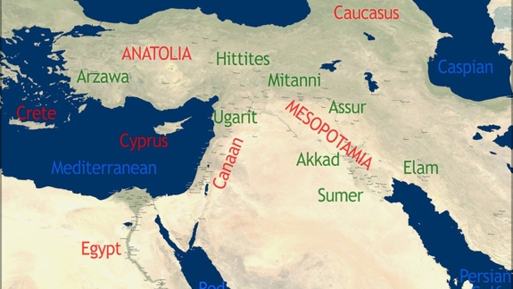

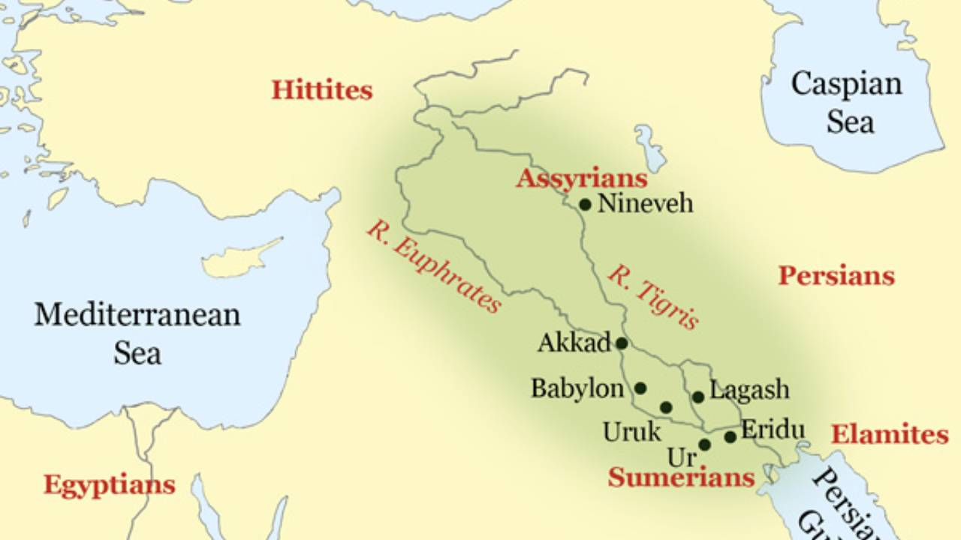

Backstory: Ancient Near East (ANE)

Archeological Discoveries in middle of 19th century

What is cuneiform writing?
- Dating

- Evolution

- Material

British Scholar George Smith

The Process
- Event
  - Collective Memory
  - Oral Tradition
  - Written Down

Biblical authors had a goal when they wrote
- They are both _________________________ and ___________________________
- The biblical authors are not trying to just teach a history lesson, but to make a ___________________________ point.

Genesis 10

Cush fathered Nimrod; he was the first on earth to be a mighty man.

The beginning of his (Nimrod’s) kingdom was Babel, Erech, Accad, and Calneh,
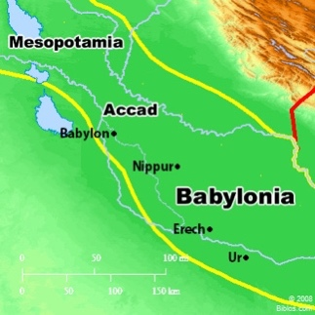
in the land of Shinar.

- Noah/Ham (Witness Flood)
- Cush
- Nimrod
- City-State
- Empires

Understanding the Mesopotamian and Ancient’s Worldview

Cosmology:
Ancient Observation

- It looks like we are in a ___________________
- On a good day what color is the sky? __________________
- What does the blue imply? ____________________

Mesopotamian

Baal Cycle
- Winter
- Spring
- Summer
- Fall

Three-Tier Structure

Other explanations for rain

Often the Old Testament was _________ false worldviews.

Ancients Religion

The gods created humans to ____________________ them

Each city-state had ___________________ deity

Mesopotamian Flood Stories

(Analyzing an ancient Sumerian story that provides insight about the flood and the giant – elements of truth and distortion)

Epic of Gilgamesh
- Gilgamesh is believed to be a real king of ____________________.
The Epic has seeds of truth with added fabrication through the years of telling.
Date: Around 2700 BC

Gilgamesh
- He is a ________________________________ character
- He is part _______________________ and part _________________________
- He is a ________________________
- New Testament writers knew the story of him
  - The Essenes/Dead Sea Scrolls

Babylonian Stories
- How did the Babylonians learn to interpret the stars, or divination, or astrology?

The Babylonian Story (before and after the flood)

- The gods (____________________________) came to Babylon before the flood and taught them the ways of the gods & civilization.
  - ______________ in number
  - “Culture _______________________”
- The divine apkallu have children that are _________________

Mesopotamian Apkallu Summary
- The Pre-flood apkallu were entirely ________________________
  - They were dispensers of divine ________________________ to humanity
  - This ___________________________ was considered ______________ by the Babylonians
- The Babylonian God _______________________(the high god ) was displeased with the Pre-flood Apkallu for not keeping with ________________________________________
  - He sentences them by ________________________ them from his presence.
  - They are sent to the _________________________
- _______________________ apkallu are mixed ancestry with humans (part god/human)
  - The hybrid apkallu were _________________________

Biblical authors are defending against __________________________ of their day
Genesis 6

Genesis 3:15
“I will put enmity between you and the woman, and between your offspring and her offspring; he shall bruise your head, and you shall bruise his heel.”

Goal: ____________________________ the line of Eve’s offspring

Genesis 6:1-6
When human beings began to increase in number on the earth and daughters were born to them, the sons of God saw that the daughters of man were attractive. And they took as their wives any they chose. Then the Lord said, “My Spirit shall not abide in man forever, for he is flesh: his days shall be 120 years.” The Nephilim were on the earth in those days, and also afterward, when the sons of God came in to the daughters of man and they bore children to them. These were the mighty men who were of old, the men of renown.
The Lord saw that the wickedness of man was great in the earth, and that every intention of the thoughts of his heart was only evil continually. And the Lord regretted that he had made man on the earth, and it grieved Him to His heart. So the Lord said, “I will blot out man whom I have created from the face of the land, man and animals and creeping things and birds of the heavens, for I am sorry that I have made them.” But Noah found favor in the eyes of the Lord.

Genesis 6:11
Now the earth was corrupt in God's sight, and the earth was filled with violence

Daughters of man:

Who are the daughters of man? ________________________________________________

Who are the ‘Sons of God’?

- Old Testament text: ‘sons of God’
  - Job 1:6
  - Job 2:1
  - Job 38:6-7
  - Psalm 89:6
- Everywhere the term ‘sons of God’ is used in the Hebrew Bible, it refers to _______________________________and not _______________________________.

Sons of God:

Who are the sons of God? ______________________________________________

Offspring: Nephilim

Who are the Nephilim?
- They are divine/human ____________________________________
- They are the ________________________

What happens to the ‘sons of God’ that cohabitated with women?
Peter and Jude –

Putting the pieces together – Genesis 6

Ancients Worldview:
Biblical Authors: Yes, there was a flood, but you got it wrong.
Yes, there were divine creatures, but you got it wrong

Babylon/Mesopotamia
- The __________________ are great
Biblical Authors
- The ___________________ are ungodly and a thread to Jewish survival

Babylon/Mesopotamia
- Babylon is great because we were taught by the _____________________
Biblical Authors
- These ___________________________ beings were ____________ creatures that taught the world the ways of evil
Nephilim
- ___________________________________
- Cast as
  - _________________________________________ (gibborim)
  - _________________________________________
- Right after the flood
  - Nimrod: Genesis 10
  - Gibborim - __________________________________________
  - Founded __________________________ and _______________________

The effect of the transgression: Genesis 6:5

